

Cervical Cancer Awareness Month

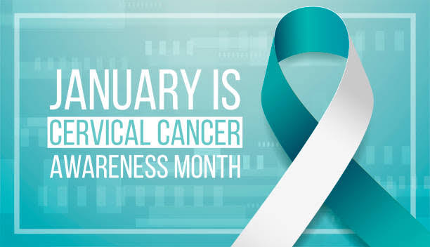

ABOUT
This social media toolkit is designed to help share standardised information about Cervical cancer. This is with a view to augment the social media strategy for Cervical Cancer Awareness Month, help manage social media accounts, implement Facebook, Twitter, Instagram, Linked In or website best practices in disseminating Cervical Cancer Awareness Month Messaging.
The National Cervical Cancer Awareness Month (CCAM) is an annual event that is celebrated every January to highlight issues around awareness, screening, prevention, early detection, diagnosis, treatment and care for cervical cancer. To realize the targets of Kenya’s Cervical Cancer Screening and Early Diagnosis Action Plan 2021-2025, there is a need to create sustained awareness among the relevant stakeholders and the general public so as to reach the eligible persons in our communities. The CCAM 2025 will be a platform for awareness, advocacy, and education of both health workers & the general public, intensified screening, empowering survivors as carriers of hope, and resource mobilization for interventions for early detection.

Social Media Handles
Below is a list of partner social handles. When relevant, please tag us on social platforms and follow our pages!
Twitter: @MOH_Kenya, @kenconetwork, @NCDAK @CancerProgram, @KenyaGovernors @UNICEFKenya, @Women4Cancer, @WHOKenya, @Cancerinkenya, @NCIKenya, @KEMRI_Kenya, @cackenya @nyaryesu @TumainiCancerIn @HENZOKENYA @KENCASA @KNH_hospital @MTRHofficial @kutrrh @FadhiliCancer @WHOKenya @KETCA254 @KenyaPhysicians @ncdalliance @NCDIpoverty @DrAhmedKalebi @CancerKisii @m_mutebi @BendaKithaka @Ca_BreastKE @KEHPCA @AfriCF @KMANairobi @CCan_org @CANCERKESHO@citizentvkenya @TheStarKenya@ntvkenya@JhpiegoKenya @KenyaGovernors @cfla_kenya @NCKenya @CDCKenya @UNAIDS_Kenya @UNFPAKen @Amref_Kenya @SurgicaltSocietyof Kenya @Roche @AstraZeneca @pfizer @uicc @OnconursesKENYA
Facebook: @MOH_Kenya, @KencoNetwork, @NCDAK @CancerProgram @NCIKenya @UNICEFKenya, @Women4Cancer @WHOKenya, @Cancerinkenya@SurgicalSocietyofKenya, @KenyaMedicalWomensAssociation @TheStarKenya @Citie @Oncology nurses Chapter Kenya

Social Media Content
- Feel free to tweak the sample posts below. Click on each visual to download directly.
- Use the hashtags #CervicalCancerAwareness, #ScreeningSavesLives, #CheckYourCervicalMonth #Cervicalcancerispreventable #ncikenya #WomensHealth

Key Messages
- Current estimates indicate that every year 5236 women are diagnosed with cervical cancer and 3211 die from the disease in Kenya.
- All women are at risk of cervical cancer.
- Cervical cancer can be treated successfully if detected early. Get a pap smear today!
- We must fight stigma, celebrate cervical cancer survivors, and encourage communities to embrace and support survivors.
- Cervical cancer ranks as the 2nd most frequent cancer among women in Kenya

Weekly Content
The suggested content will focus on specific themes every week as follows:
- Week 1 (1st to 7th Jan): Cervical cancer in context
- Week 2 (8th to 14th Jan): Risk factors of cervical cancer and taking action.
- Week 3 (15th to 21st Jan): Signs and Symptoms, and taking action
- Week 4 (21st to end of Jan): Prevention

Suggested Posts
Date | Content-Type | Twitter | Facebook /LinkedIn | Instagram
1st Jan 2025 |  | January is Cervical Cancer Awareness Month. It is a perfect opportunity for NCI-K and partners to raise awareness about cervical cancer and HPV vaccination.  Current estimates indicate that every year 5236 women are diagnosed with cervical cancer and 3211 die from the disease in Kenya. The disease is preventable with vaccination and appropriate screening.  #CervicalCancerAwareness | January is Cervical Cancer Awareness Month. It is a perfect opportunity for NCI-K and partners to raise awareness about cervical cancer and HPV vaccination.  Current estimates indicate that every year 5236 women are diagnosed with cervical cancer and 3211 die from the disease in Kenya. The disease is preventable with vaccination and appropriate screening.  #CervicalCancerAwareness | January is Cervical Cancer Awareness Month. It is a perfect opportunity for NCI-K and partners to raise awareness about cervical cancer and HPV vaccination.  Current estimates indicate that every year 5236 women are diagnosed with cervical cancer and 3211 die from the disease in Kenya. The disease is preventable with vaccination and appropriate screening.  #CervicalCancerAwareness
2nd Jan 2025 | 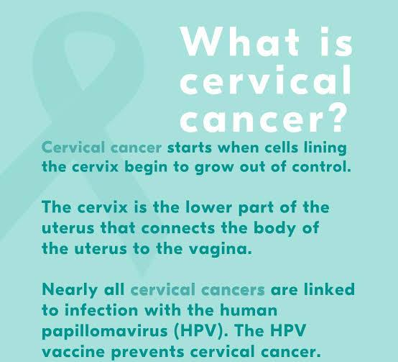 | What is Cervical Cancer? Cervical cancer starts when cells lining the cervix begin to grow out of control. The cervix is the lower part of the uterus that connects the body of the uterus to the vagina.  Nearly all the cervical cancers are linked to infection with the Human Papillomavirus (HPV). Good news though is that HPV vaccine, which prevents cervical cancer is available freely in Kenya.  #endcervicalcancer #cervicalcancerawarenessmonth #screeningsaveslives #ncikenya | What is Cervical Cancer? Cervical cancer starts when cells lining the cervix begin to grow out of control. The cervix is the lower part of the uterus that connects the body of the uterus to the vagina.  Nearly all the cervical cancers are linked to infection with the Human Papillomavirus (HPV). Good news though is that HPV vaccine, which prevents cervical cancer is available freely in Kenya.  #endcervicalcancer #cervicalcancerawarenessmonth #screeningsaveslives #ncikenya | What is Cervical Cancer? Cervical cancer starts when cells lining the cervix begin to grow out of control. The cervix is the lower part of the uterus that connects the body of the uterus to the vagina.  Nearly all the cervical cancers are linked to infection with the Human Papillomavirus (HPV). Good news though is that HPV vaccine, which prevents cervical cancer is available freely in Kenya.  #endcervicalcancer #cervicalcancerawarenessmonth #screeningsaveslives #ncikenya
3rd Jan 2025 | 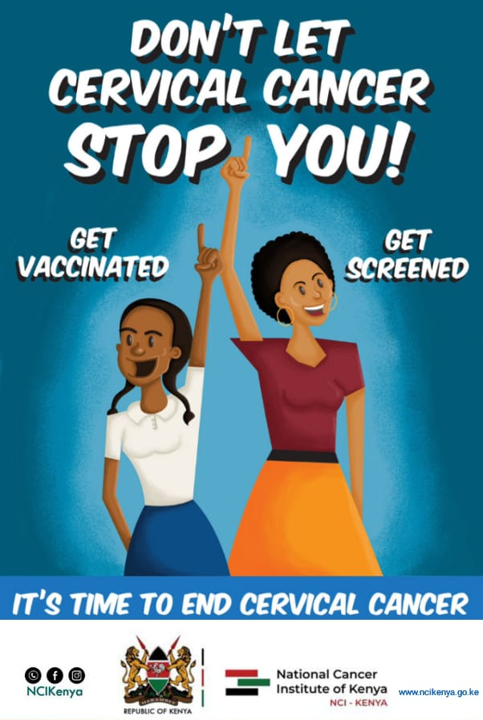 | Do not let cervical cancer stop you! Get screened, get vaccinated. Cervical cancer can be defeated.  #EarlyDetectionSavesLives  #CancerAwareness #cervicalcancerawareness #cervicalcancerawarenessmonth | Did you know that Cervical cancer ranks as the second-leading cause of cancer-related deaths in the country? Cervical cancer claims the lives of 7 women in Kenya every day.  #EarlyDetectionSavesLives  #CancerAwareness | Did you know that Cervical cancer ranks as the second-leading cause of cancer-related deaths in the country? Cervical cancer claims the lives of 7 women in Kenya every day.  #EarlyDetectionSavesLives  #CancerAwareness
4th Jan 2025 | 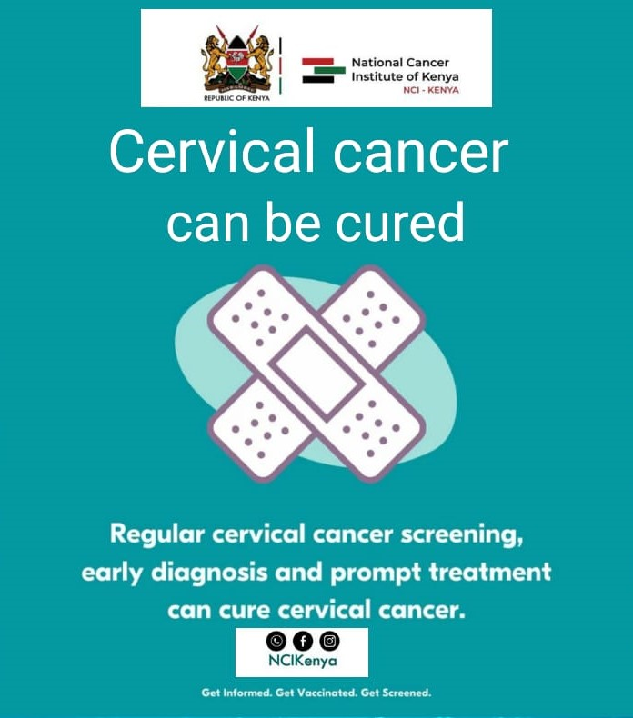 | Cervical cancer can be prevented through vaccination, regular screening of women and treatment of pre-cancerous lesions.  #EarlyDetectionSavesLives  #screeningpreventscancer | The majority of Cervical cancer cases in Kenya are discovered at stage IV, accounting for 37.2% of all cases. This reduces the likelihood of survival. Be screened early!  #EarlyDetectionSavesLives | The majority of Cervical cancer cases in Kenya are discovered at stage IV, accounting for 37.2% of all cases. This reduces the likelihood of survival. Be screened early!  #EarlyDetectionSavesLives  #Health, #Hope, #Janober
5th Jan 2025 | 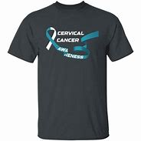 | Dear Kenyans, January being the cervical cancer awareness month, let us try putting on cancer branded attire to help create awareness.  Put on T-shirts, caps, scarves, headscarves and wrist bands bearing cervical cancer awareness messages. We can do this together, we can fight cervical cancer.  #cervicalcancer #ncikenya #cervicalcancerawareness #cervicalcancerawarenessmonth #endcervicalcancer | Dear Kenyans, January being the cervical cancer awareness month, let us try putting on cancer branded attire to help create awareness.  Put on T-shirts, caps, scarves and wrist bands bearing cervical cancer awareness messages. We can do this together, we can fight cervical cancer.  #cervicalcancer #ncikenya #cervicalcancerawareness #cervicalcancerawarenessmonth #endcervicalcancer | Dear Kenyans, January being the cervical cancer awareness month, let us try putting on cancer branded attire to help create awareness.  Put on T-shirts, caps, scarfs and wrist bands bearing cervical cancer awareness messages. We can do this together, we can fight cervical cancer.  #cervicalcancer #ncikenya #cervicalcancerawareness #cervicalcancerawarenessmonth #endcervicalcancer
6th Jan 2025 | 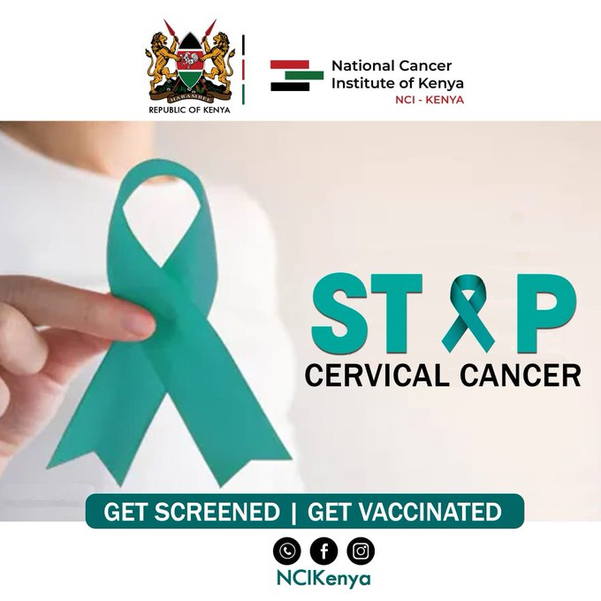 | Kenya, through the National Cancer Institute is fully in line with the WHO’s Cervical Cancer Elimination Strategy of 90-70-90%. To mean:  90% of girls fully vaccinated with the HPV vaccine by the age of 15.  70% of women are screened with a high-performance test by 35 years of age and again by 45 years of age.  90% of women identified with cervical disease receive treatment  #ScreeningSavesLives #EarlyDetectionSavesLives  #screeningpreventscancer  #cervicalcancerawareness | Kenya, through the National Cancer Institute is fully in line with the WHO’s Cervical Cancer Elimination Strategy of 90-70-90%. To mean:  90% of girls fully vaccinated with the HPV vaccine by the age of 15.  70% of women are screened with a high-performance test by 35 years of age and again by 45 years of age.  90% of women identified with cervical disease receive treatment  #ScreeningSavesLives #EarlyDetectionSavesLives  #screeningpreventscancer  #cervicalcancerawareness | Kenya, through the National Cancer Institute is fully in line with the WHO’s Cervical Cancer Elimination Strategy of 90-70-90%. To mean:  90% of girls fully vaccinated with the HPV vaccine by the age of 15.  70% of women are screened with a high-performance test by 35 years of age and again by 45 years of age.  90% of women identified with cervical disease receive treatment  #ScreeningSavesLives #EarlyDetectionSavesLives  #screeningpreventscancer  #cervicalcancerawareness
7th Jan 2025 | 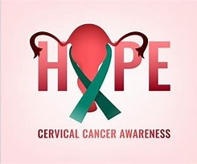 | Cervical cancer contributes approximately 12% of all cancer cases diagnosed in Kenya, and is the leading cause of cancer mortality in Kenya, with an estimated 3,200 deaths every year.  We can reduce this by vaccinating our girls between ages 9-15 and getting screened for cervical cancer. We encourage all Kenyans to share this information to widen the scope of our cancer awareness.  The National Cancer Institute of Kenya continues leading the response against cancer in the country.  #hpvvaccination  #cervicalcancerawareness  #endcervicalcancer  #ncikenya | Cervical cancer contributes approximately 12% of all cancer cases diagnosed in Kenya, and is the leading cause of cancer mortality in Kenya, with an estimated 3,200 deaths every year.  We can reduce this by vaccinating our girls between ages 9-15 and getting screened for cervical cancer. We encourage all Kenyans to share this information to widen the scope of our cancer awareness.  The National Cancer Institute of Kenya will continue leading the response against cancer in the country.  #hpvvaccination  #cervicalcancerawareness  #endcervicalcancer  #ncikenya | Cervical cancer contributes approximately 12% of all cancer cases diagnosed in Kenya, and is the leading cause of cancer mortality in Kenya, with an estimated 3,200 deaths every year.  We can reduce this by vaccinating our girls between ages 9-15 and getting screened for cervical cancer. We encourage all Kenyans to share this information to widen the scope of our cancer awareness.  The National Cancer Institute of Kenya will continue leading the response against cancer in the country.  #hpvvaccination  #cervicalcancerawareness  #endcervicalcancer  #ncikenya
9th Jan 2025 | 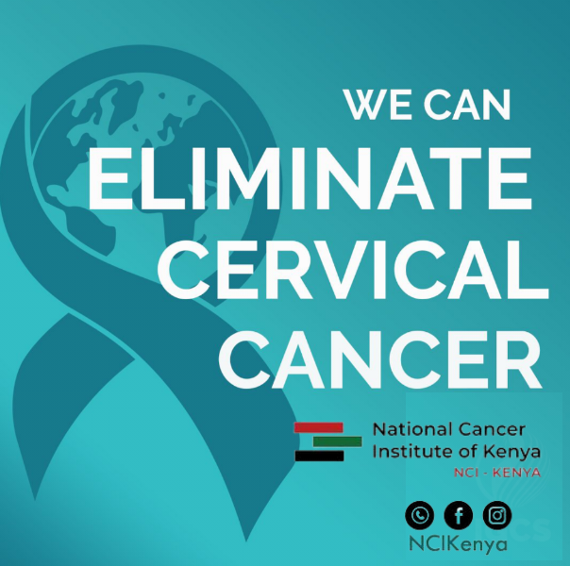 | We can eliminate cervical cancer. Ensuring that the girl child between 9 & 15 years get vaccinated against HPV is the main way of eliminating cancer.  We urge parents to be part of this fight by ensuring their girls are vaccinated. HPV vaccine is available freely in all primary health care facilities.  #hpvvaccination  #cervicalcancerawareness  #endcervicalcancer  #ncikenya  #cervicalcancer | We can eliminate cervical cancer. Ensuring that the girl child between 9 & 15 years get vaccinated against HPV is the main way of eliminating cancer.  We urge parents to be part of this fight by ensuring their girls are vaccinated. HPV vaccine is available freely in all primary health care facilities.  #hpvvaccination  #cervicalcancerawareness  #endcervicalcancer  #ncikenya  #cervicalcancer | We can eliminate cervical cancer. Ensuring that the girl child between 9 & 15 years get vaccinated against HPV is the main way of eliminating cancer.  We urge parents to be part of this fight by ensuring their girls are vaccinated. HPV vaccine is available freely in all primary health care facilities.  #hpvvaccination  #cervicalcancerawareness  #endcervicalcancer  #ncikenya  #cervicalcancer
10th Jan 2025 | 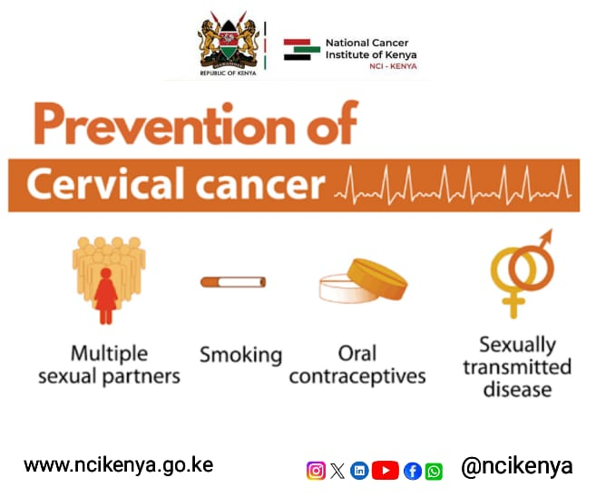 | Risk Factors for Cervical Cancer  Majority of cervical cancer is caused by a virus called human papillomavirus. HPV spreads through sexual contact with a person who already possess it. It is worth nothing that not all types of HPV causes cervical cancer.  Some of them cause genital warts, but other types may not cause any infections  - The risk factors include:  - Multiple sexual partners  - Having sex at early age  - Sexually transmitted infections such as chlamydia, gonorrhea, syphilis and HIV/AIDS  - Smoking  #CervicalCancerAwarenes #ncikenya #endcervicalcancer | Risk Factors for Cervical Cancer  Majority of cervical cancer is caused by a virus called human papillomavirus. HPV spreads through sexual contact with a person who already possess it is worth nothing that not all types of HPV causes cervical cancer.  Some of them cause genital warts, but other types may not cause any infections  - The risk factors include:  - Multiple sexual partners  - Having sex at early age  - Sexually transmitted infections such as chlamydia, gonorrhea, syphilis and HIV/AIDS  - Smoking  #CervicalCancerAwarenes #ncikenya #endcervicalcancer | Risk Factors for Cervical Cancer  Majority of cervical cancer is caused by a virus called human papillomavirus. HPV spreads through sexual contact with a person who already possess it is worth nothing that not all types of HPV causes cervical cancer.  Some of them cause genital warts, but other types may not cause any infections  - The risk factors include:  - Multiple sexual partners  - Having sex at early age  - Sexually transmitted infections such as chlamydia, gonorrhea, syphilis and HIV/AIDS  - Smoking  #CervicalCancerAwarenes #ncikenya #endcervicalcancer
11th Jan 2025 | 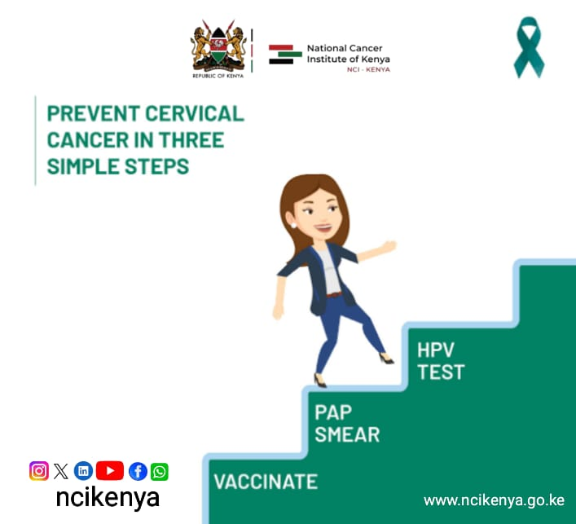 | The main cause of cervical cancer is human papillomavirus (HPV), a common infection that can be transmitted through sexual contact or skin-to-skin contact. Prevent it in three main steps  - Vaccinate  - Pap smear  - HPV test  #CancerAwareness #ncikenya #hpvvaccination #endcervicalcancer | The main cause of cervical cancer is human papillomavirus (HPV), a common infection that can be transmitted through sexual contact or skin-to-skin contact. Prevent it in three main steps  - Vaccinate  - Pap smear  - HPV test  #CancerAwareness #ncikenya #hpvvaccination #endcervicalcancer | The main cause of cervical cancer is human papillomavirus (HPV), a common infection that can be transmitted through sexual contact or skin-to-skin contact. Prevent it in three main steps  - Vaccinate  - Pap smear  - HPV test  #CancerAwareness #ncikenya #hpvvaccination #endcervicalcancer
12th Jan 2025 | 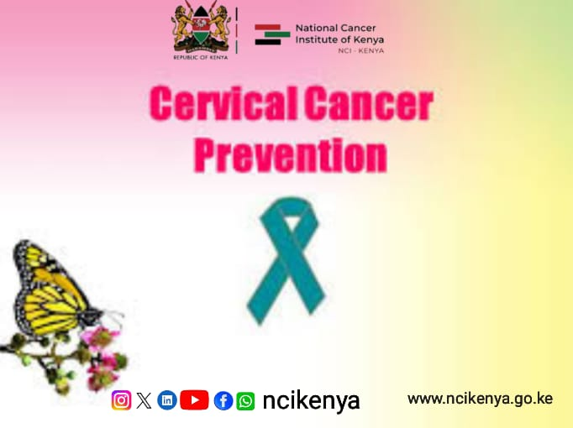 | There are many types of HPV, but some are more likely to cause cervical cancer than others. HPV types 16 and 18 are responsible for about 70% of cervical cancer cases. Get screened today to be save.  #GetScreened #cervicalcancerscreening #ncikenya  #ActNow! | There are many types of HPV, but some are more likely to cause cervical cancer than others. HPV types 16 and 18 are responsible for about 70% of cervical cancer cases. Get screened today to be save.  #GetScreened #cervicalcancerscreening #ncikenya  #ActNow! | There are many types of HPV, but some are more likely to cause cervical cancer than others. HPV types 16 and 18 are responsible for about 70% of cervical cancer cases. Get screened today to be save.  #GetScreened #cervicalcancerscreening #ncikenya  #ActNow!
15th Jan 2025 | 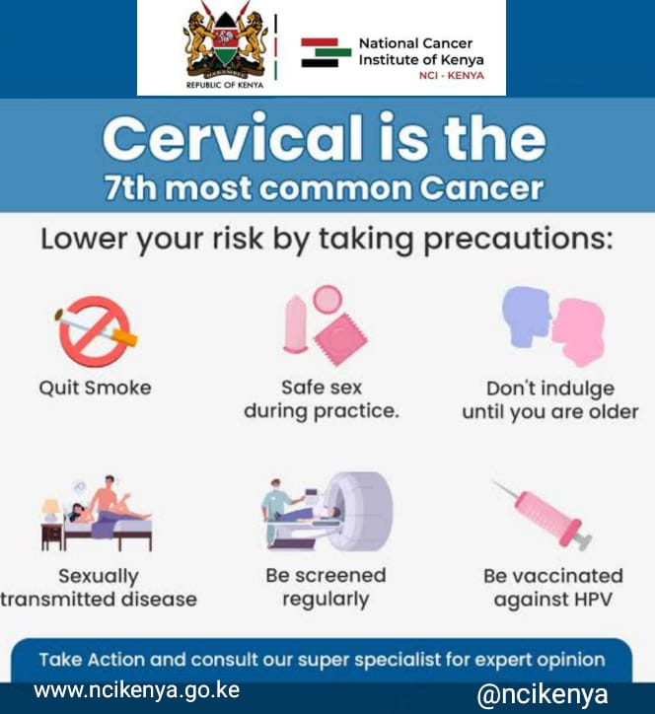 | Other factors that can increase the risk of cervical cancer include having a weak immune system, smoking, using birth control pills for a long time, and having multiple sexual partners or a partner with HPV. Practice safe sex to protect yourself  #screeningsaveslives #cancerawareness #cervicalcancerawareness #ncikenya | Other factors that can increase the risk of cervical cancer include having a weak immune system, smoking, using birth control pills for a long time, and having multiple sexual partners or a partner with HPV. Practice safe sex to protect yourself  #screeningsaveslives #cancerawareness #cervicalcancerawareness #ncikenya | Other factors that can increase the risk of cervical cancer include having a weak immune system, smoking, using birth control pills for a long time, and having multiple sexual partners or a partner with HPV. Practice safe sex to protect yourself  #screeningsaveslives #cancerawareness #cervicalcancerawareness #ncikenya
15th Jan 2025 | 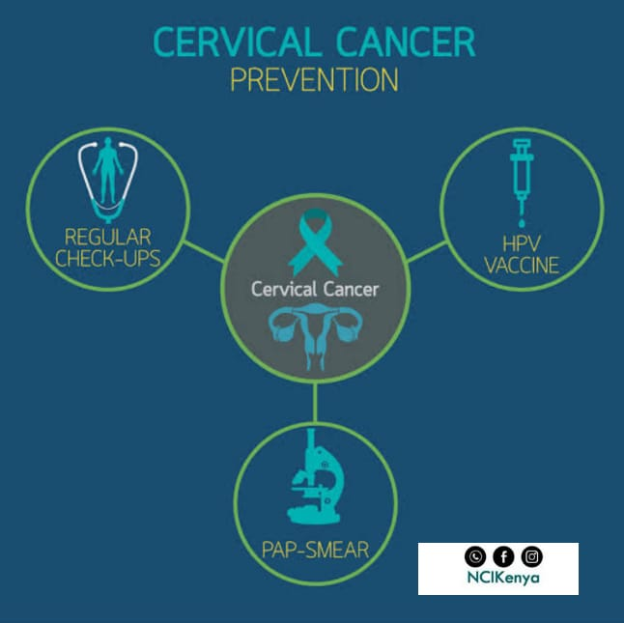 | Cervical cancer can be prevented by getting vaccinated against HPV, having regular Pap tests and HPV tests, and avoiding or limiting the risk factors including having multiple partners. HPV vaccine is freely available for all girls in Kenya, ages 9 – 15.  #CervicalCancerAwareness #getscreened #ncikenya #cancerawareness | Cervical cancer can be prevented by getting vaccinated against HPV, having regular Pap tests and HPV tests, and avoiding or limiting the risk factors including having multiple partners. HPV vaccine is freely available for all girls in Kenya, ages 9 – 15.  #CervicalCancerAwareness #getscreened #ncikenya #cancerawareness | Cervical cancer can be prevented by getting vaccinated against HPV, having regular Pap tests and HPV tests, and avoiding or limiting the risk factors including having multiple partners. HPV vaccine is freely available for all girls in Kenya, ages 9 – 15.  #CervicalCancerAwareness #getscreened #ncikenya #cancerawareness
16th Jan 2025 | 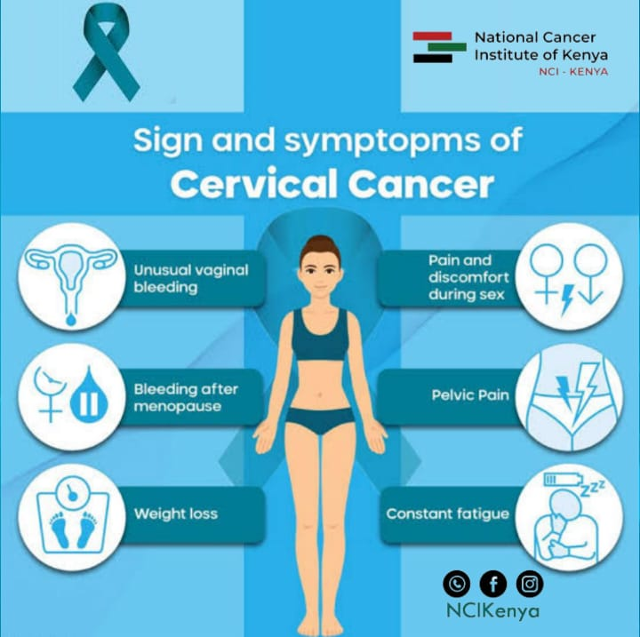 | Signs and Symptoms of Cervical Cancer.  - Unusual vaginal bleeding  - Bleeding after menopause  - Weight loss  - Pain and discomfort during sex  - Pelvic pain  - Constant fatigue  Present yourself to the doctor for examination and advice when you experience any of these signs. Remember, prevention is better than cure  #EarlyDetectionSavesLives  #screeningpreventscancer  #cervicalcancerawareness | Signs and Symptoms of Cervical Cancer.  - Unusual vaginal bleeding  - Bleeding after menopause  - Weight loss  - Pain and discomfort during sex  - Pelvic pain  - Constant fatigue  Present yourself to the doctor for examination and advice when you experience any of these signs. Remember, prevention is better than cure  #EarlyDetectionSavesLives  #screeningpreventscancer  #cervicalcancerawareness | Signs and Symptoms of Cervical Cancer.  - Unusual vaginal bleeding  - Bleeding after menopause  - Weight loss  - Pain and discomfort during sex  - Pelvic pain  - Constant fatigue  Present yourself to the doctor for examination and advice when you experience any of these signs. Remember, prevention is better than cure  #EarlyDetectionSavesLives  #screeningpreventscancer  #cervicalcancerawareness
17th Jan 2025 | 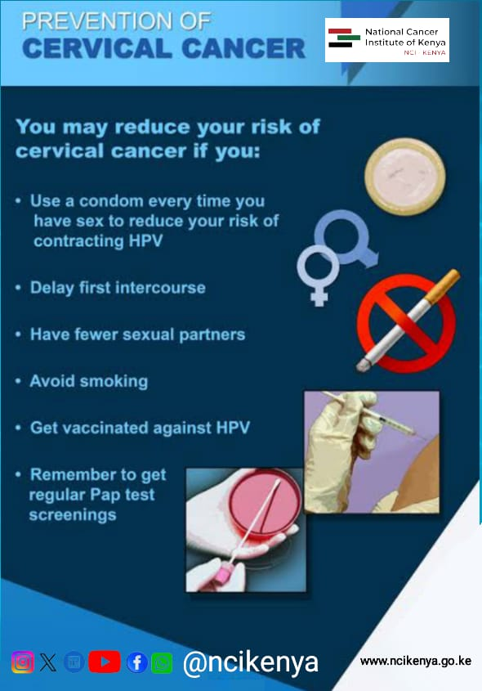 | Cervical cancer risk factors that can be avoided.  - HPV Infection – this can be avoided through vaccination.  - Sexual history – being sexually active at a younger age (less than 16), having multiple partners  - Smoking  - Long-term use of oral contraceptives  - A diet low in fruits and vegetables  #cancerscreening #gewtscreened #cancerawareness #ncikenya #ScreeningSavesLives | Cervical cancer risk factors that can be avoided.  - HPV Infection – this can be avoided through vaccination.  - Sexual history – being sexually active at a younger age (less than 16), having multiple partners  - Smoking  - Long-term use of oral contraceptives  - A diet low in fruits and vegetables  #cancerscreening #gewtscreened #cancerawareness #ncikenya #ScreeningSavesLives | Cervical cancer risk factors that can be avoided.  - HPV Infection – this can be avoided through vaccination.  - Sexual history – being sexually active at a younger age (less than 16), having multiple partners  - Smoking  - Long-term use of oral contraceptives  - A diet low in fruits and vegetables  #cancerscreening #gewtscreened #cancerawareness #ncikenya #ScreeningSavesLives
18th Jan 2025 |  | Main types of Cervical screening include:  - HPV test: looks for the virus (human papillomavirus) that can cause cell changes on the cervix.  - Pap test (or Pap smear): looks for precancers, cell changes on the cervix that might become cervical cancer if they are not treated appropriately.  Take a step today and get screened.  #cervicalcancerawarenessmonth #cervicalcancerawareness #cancerawarenes #ncikenya#ScreeningSavesLives | Main types of Cervical screening include:  - HPV test: looks for the virus (human papillomavirus) that can cause cell changes on the cervix.  - Pap test (or Pap smear): looks for precancers, cell changes on the cervix that might become cervical cancer if they are not treated appropriately.  Take a step today and get screened.  #cervicalcancerawarenessmonth #cervicalcancerawareness #cancerawarenes #ncikenya#ScreeningSavesLives | Main types of Cervical screening include:  - HPV test: looks for the virus (human papillomavirus) that can cause cell changes on the cervix.  - Pap test (or Pap smear): looks for precancers, cell changes on the cervix that might become cervical cancer if they are not treated appropriately.  Take a step today and get screened.  #cervicalcancerawarenessmonth #cervicalcancerawareness #cancerawarenes #ncikenya#ScreeningSavesLives
19th Jan 2025 | 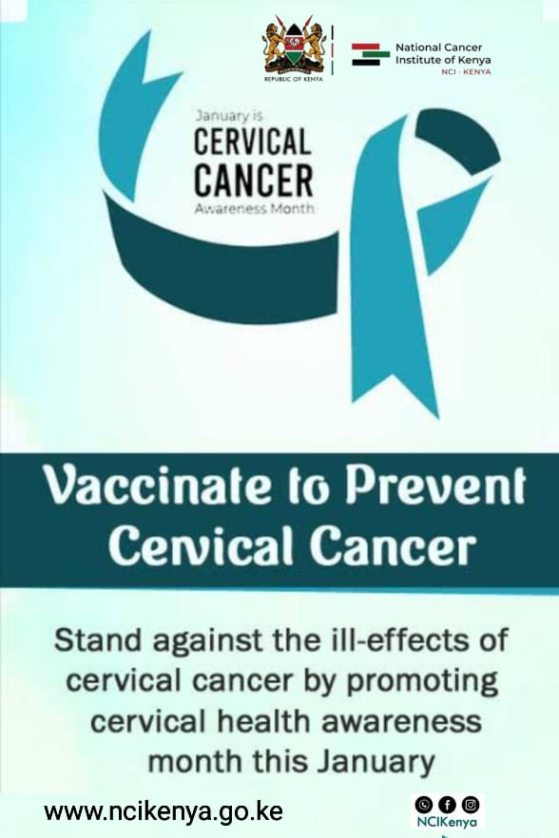 | All adult women should undergo periodic #cervicalcancer screening. Screening aims to detect precancerous lesions, that is, abnormalities in the cells of the cervix, which, if left untreated, can develop into cervical cancer. When found, precancerous lesions must be treated.  #getvaccinated #getscreenedtoday #screeningsaveslives #ncikenya | All adult women should undergo periodic #cervicalcancer screening. Screening aims to detect precancerous lesions, that is, abnormalities in the cells of the cervix, which, if left untreated, can develop into cervical cancer. When found, precancerous lesions must be treated.  #getvaccinated #getscreened today #screeningsaveslives #ncikenya | All adult women should undergo periodic #cervicalcancer screening. Screening aims to detect precancerous lesions, that is, abnormalities in the cells of the cervix, which, if left untreated, can develop into cervical cancer. When found, precancerous lesions must be treated.  #getvaccinated #getscreened today #screeningsaveslives #ncikenya
19th Jan 2025 | 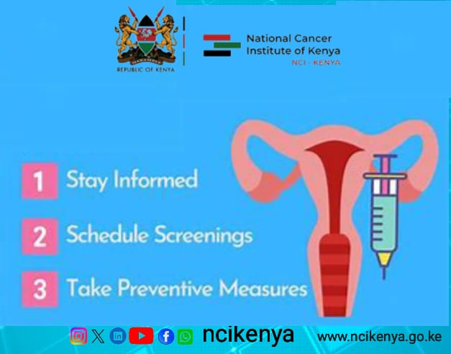 | The most important things you can do to help prevent cervical cancer are to get vaccinated against HPV, have regular screening tests, and go back to the doctor if your screening test results are not normal.  #getvaccinated #getscreened today #screeningsaveslives #ncikenya | The most important things you can do to help prevent cervical cancer are to get vaccinated against HPV, have regular screening tests, and go back to the doctor if your screening test results are not normal.  #getvaccinated #getscreened today #screeningsaveslives #ncikenya | The most important things you can do to help prevent cervical cancer are to get vaccinated against HPV, have regular screening tests, and go back to the doctor if your screening test results are not normal.  #getvaccinated #getscreened today #screeningsaveslives #ncikenya
20th Jan 2025 | 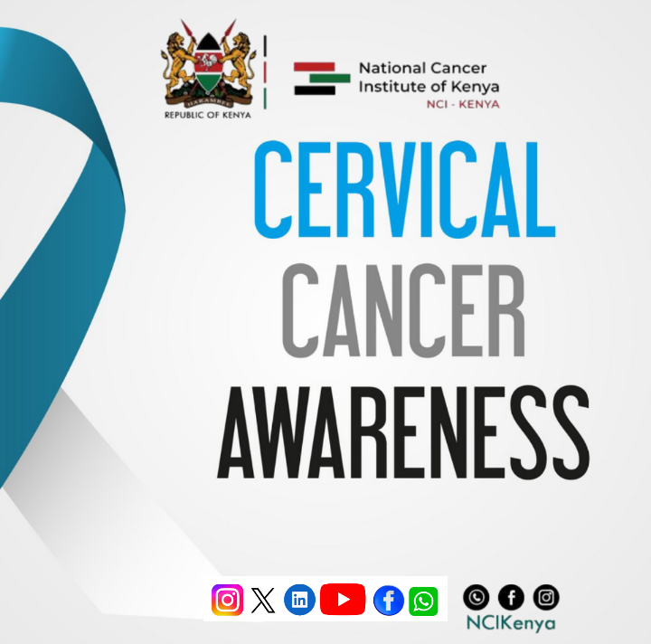 | No one should die of #cervicalcancer in Kenya. It is preventable. In aligning to @WHO 's strategy on elimination of cervical cancer, the government of Kenya, through the ministry of Health, @MOH_Kenya has provided free #HPV vaccination which aims a 90% full vaccination of girls by age 15 years by the year 2030.  #cervicalcancerawareness #cancerawareness #ncikenya #endcervicalcancer | No one should die of #cervicalcancer in Kenya. It is preventable. In aligning to @WHO 's strategy on elimination of cervical cancer, the government of Kenya, through the ministry of Health, @MOH_Kenya has provided free #HPV vaccination which aims a 90% full vaccination of girls by age 15 years by the year 2030.  #cervicalcancerawareness #cancerawareness #ncikenya #endcervicalcancer | No one should die of #cervicalcancer in Kenya. It is preventable. In aligning to @WHO 's strategy on elimination of cervical cancer, the government of Kenya, through the ministry of Health, @MOH_Kenya has provided free #HPV vaccination which aims a 90% full vaccination of girls by age 15 years by the year 2030.  #cervicalcancerawareness #cancerawareness #ncikenya #endcervicalcancer
21st Jan 2025 |  | Prevention of Cervical  Cervical cancer risks can be prevented by:  - Getting vaccinated against HPV from age 9 to 15. Vaccine is effective if administered before they turn sexually active  - Regular pap smear tests to detect the cancerous conditions of the cervix after 35 years  - Safe sexual practices such as using condoms  - Avoid smoking  #cervicalcancerawarenessmonth #cervicalcancerawareness #cancerawarenes #ncikenya#ScreeningSavesLives | Prevention of Cervical  Cervical cancer risks can be prevented by:  - Getting vaccinated against HPV from age 9 to 15. Vaccine is effective if administered before they turn sexually active  - Regular pap smear tests to detect the cancerous conditions of the cervix after 35 years  - Safe sexual practices such as using condoms  - Avoid smoking  #cervicalcancerawarenessmonth #cervicalcancerawareness #cancerawarenes #ncikenya#ScreeningSavesLives | Prevention of Cervical  Cervical cancer risks can be prevented by:  - Getting vaccinated against HPV from age 9 to 15. Vaccine is effective if administered before they turn sexually active  - Regular pap smear tests to detect the cancerous conditions of the cervix after 35 years  - Safe sexual practices such as using condoms  - Avoid smoking  #cervicalcancerawarenessmonth #cervicalcancerawareness #cancerawarenes #ncikenya#ScreeningSavesLives
23rd Jan 2025 | 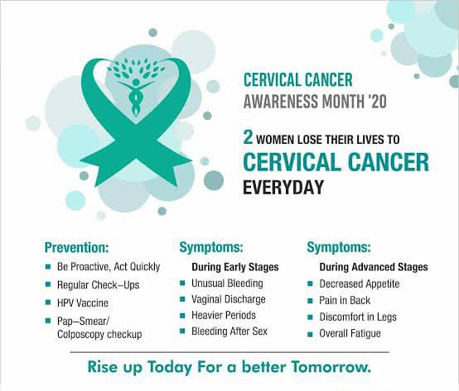 | Signs and Symptoms of Cervical Cancer  Initial stages of cervical cancer show no signs or symptoms. Signs and side effects of further developed cervical cancer include:  - Vaginal bleeding after intercourse  - Abnormal Vaginal discharge with foul odor  - Pelvic pain during intercourse  When you notice these symptoms, or if you know someone exhibiting them, then seek medical attention immediately  #Cervicalcancerawareness #ncikenya #screeningsavelives #endcervicalcancer | Signs and Symptoms of Cervical Cancer  Initial stages of cervical cancer show no signs or symptoms. Signs and side effects of further developed cervical cancer include:  - Vaginal bleeding after intercourse  - Abnormal Vaginal discharge with foul odor  - Pelvic pain during intercourse  When you notice these symptoms, or if you know someone exhibiting them, then seek medical attention immediately  #Cervicalcancerawareness #ncikenya #screeningsavelives #endcervicalcancer | Signs and Symptoms of Cervical Cancer  Initial stages of cervical cancer show no signs or symptoms. Signs and side effects of further developed cervical cancer include:  - Vaginal bleeding after intercourse  - Abnormal Vaginal discharge with foul odor  - Pelvic pain during intercourse  When you notice these symptoms, or if you know someone exhibiting them, then seek medical attention immediately  #Cervicalcancerawareness #ncikenya #screeningsavelives #endcervicalcancer
24th Jan 2025 | 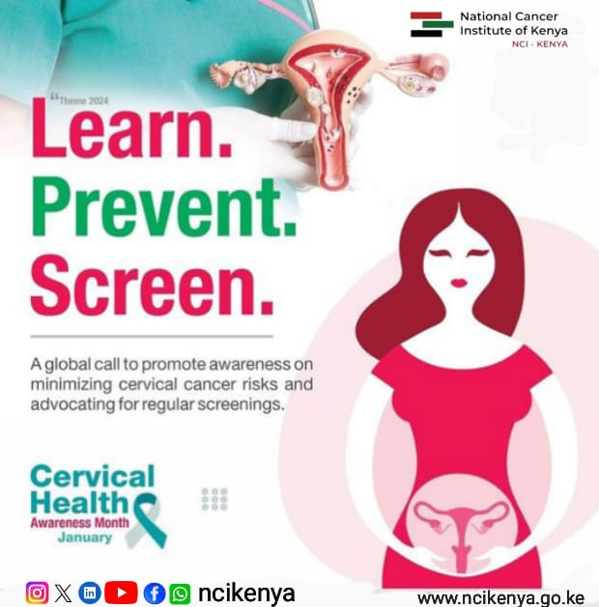 | What causes most cases of cervical cancer?  A virus  The human papillomavirus (HPV) is the main cause of cervical cancer. HPV is very common in kenya and is passed from one person to another during sex or through any sexual contact.  #Cervicalcancerawareness #ncikenya #screeningsavelives #endcervicalcancer | What causes most cases of cervical cancer?  A virus  The human papillomavirus (HPV) is the main cause of cervical cancer. HPV is very common in kenya and is passed from one person to another during sex or through any sexual contact.  #Cervicalcancerawareness #ncikenya #screeningsavelives #endcervicalcancer | What causes most cases of cervical cancer?  A virus  The human papillomavirus (HPV) is the main cause of cervical cancer. HPV is very common in kenya and is passed from one person to another during sex or through any sexual contact.  #Cervicalcancerawareness #ncikenya #screeningsavelives #endcervicalcancer
25th Jan 2025 | 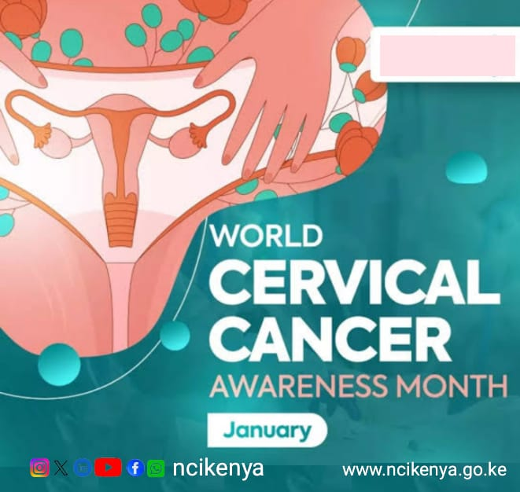 | Should everyone get the HPV vaccine?  NO.  HPV vaccination is recommended for children who are 9 to 15 years old. It is also recommended for everyone through age 26, if they are not vaccinated already. HPV vaccination is not recommended for everyone older than age 26.  #cervicalcancerawareness #cancerawareness #ncikenya #endcervicalcancer | Should everyone get the HPV vaccine?  NO.  HPV vaccination is recommended for children who are 9 to 15 years old. It is also recommended for everyone through age 26, if they are not vaccinated already. HPV vaccination is not recommended for everyone older than age 26.  #cervicalcancerawareness #cancerawareness #ncikenya #endcervicalcancer | Should everyone get the HPV vaccine?  NO.  HPV vaccination is recommended for children who are 9 to 15 years old. It is also recommended for everyone through age 26, if they are not vaccinated already. HPV vaccination is not recommended for everyone older than age 26.  #cervicalcancerawareness #cancerawareness #ncikenya #endcervicalcancer
26th Jan 2025 | 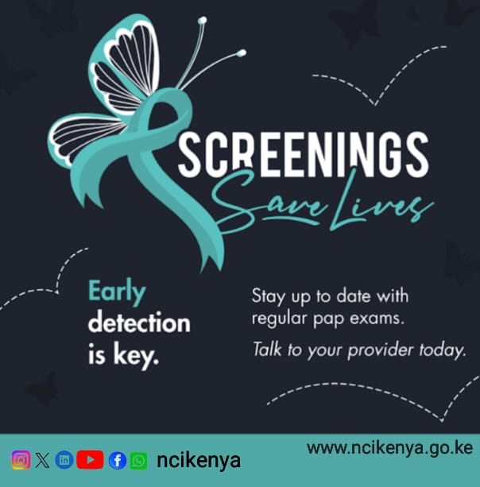 | To lower your risk for cervical cancer, get screened as recommended, and get the HPV vaccine if you are in the age group for which it’s recommended (9 – 15years).  #hope #ncikenya #cervicalcancer #cervicalcancerawreness #cervicalcancerawarenessmonth #endcervicalcancer | To lower your risk for cervical cancer, get screened as recommended, and get the HPV vaccine if you are in the age group for which it’s recommended (9 – 15years).  #hope #ncikenya #cervicalcancer #cervicalcancerawreness #cervicalcancerawarenessmonth #endcervicalcancer | To lower your risk for cervical cancer, get screened as recommended, and get the HPV vaccine if you are in the age group for which it’s recommended (9 – 15years).  #hope #ncikenya #cervicalcancer #cervicalcancerawreness #cervicalcancerawarenessmonth #endcervicalcancer
29th Jan 2025 | 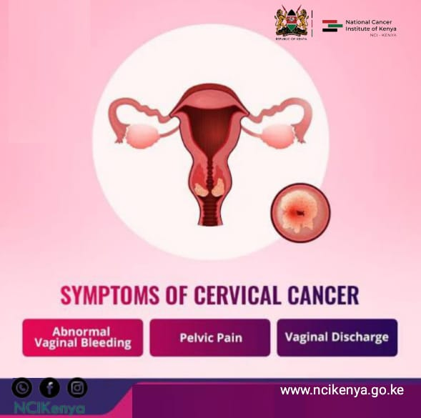 | Remember that you should get screened for cervical cancer regularly, even if you received an HPV vaccine.  #hope #ncikenya #cervicalcancer #cervicalcancerawreness #cervicalcancerawarenessmonth #endcervicalcancer | Remember that you should get screened for cervical cancer regularly, even if you received an HPV vaccine.  #hope #ncikenya #cervicalcancer #cervicalcancerawreness #cervicalcancerawarenessmonth #endcervicalcancer | Remember that you should get screened for cervical cancer regularly, even if you received an HPV vaccine.  #hope #ncikenya #cervicalcancer #cervicalcancerawreness #cervicalcancerawarenessmonth #endcervicalcancer
30th Jan 2025 | 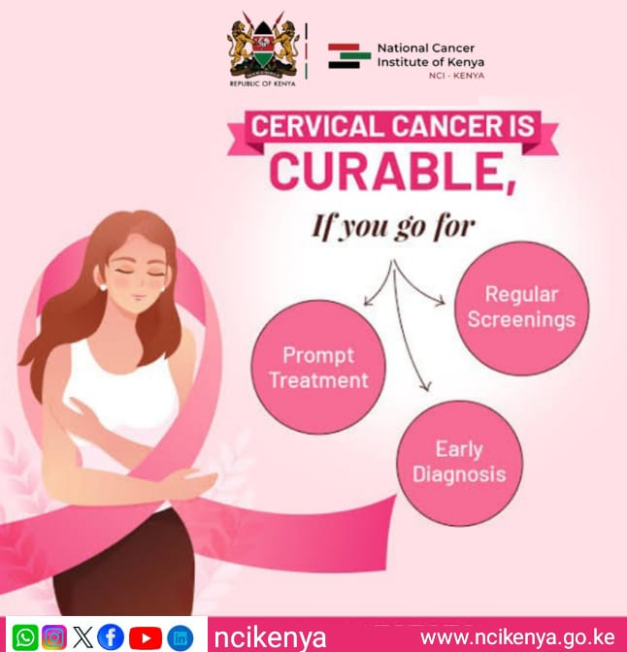 | The best age for one to start getting Pap tests is at age 21. Get screened today.  #hope #ncikenya #cervicalcancer #cervicalcancerawreness #cervicalcancerawarenessmonth #endcervicalcancer | The best age for one to start getting Pap tests is at age 21. Get screened today.  #hope #ncikenya #cervicalcancer #cervicalcancerawreness #cervicalcancerawarenessmonth #endcervicalcancer | The best age for one to start getting Pap tests is at age 21. Get screened today.  #hope #ncikenya #cervicalcancer #cervicalcancerawreness #cervicalcancerawarenessmonth #endcervicalcancer
30th Jan 2025 | 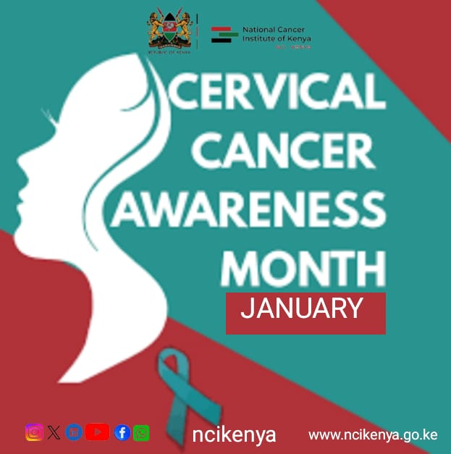 | Stigma feeds fear and ignorance, leading to silence. Let us shun this harmful cycle and create a more supportive environment for those with cancer.  #Breakstigma  #LetsTalkaboutcancer  #Cervicalcancer  #ScreeningSaveLives | Stigma feeds fear and ignorance, leading to silence. Let us shun this harmful cycle and create a more supportive environment for those with cancer. By ending stigma, we can also shift public attitudes towards prevention and early detection.  #Breakstigma  #LetsTalkaboutcancer  #Cervicalcancer  #ScreeningSaveLives | Stigma feeds fear and ignorance, leading to silence. Let us shun this harmful cycle and create a more supportive environment for those with cancer.  #Breakstigma  #LetsTalkaboutcancer  #Cervicalcancer  #ScreeningSaveLives
31st Jan 2025 | 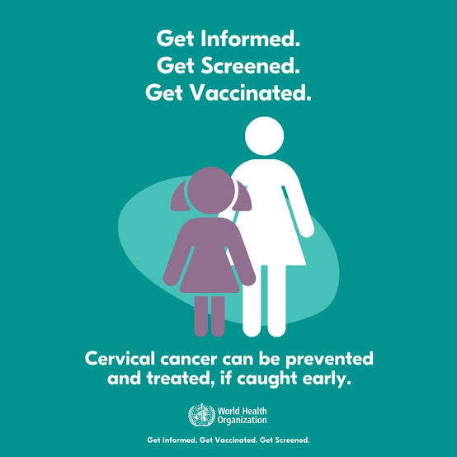 | Cervical cancer is one of the most common cancers in women and there is a misconception among people that it only happens to older women. While it’s true that most Cervical cancers are found in women who are 40 years or older, it is imperative to know that it can strike any female at any age.  #Cervicalcancer #cancerawareness #Cervicalcancerawareness | Cervical cancer is one of the most common cancers in women and there is a misconception among people that it only happens to older women. While it’s true that most Cervical cancers are found in women who are 40 years or older, it is imperative to know that it can strike any female at any age.  #Cervicalcancer #cancerawareness #Cervicalcancerawareness | Cervical cancer is one of the most common cancers in women and there is a misconception among people that it only happens to older women. While it’s true that most Cervical cancers are found in women who are 40 years or older, it is imperative to know that it can strike any female at any age.  #Cervicalcancer #cancerawareness #Cervicalcancerawareness
31st Jan 2025 | 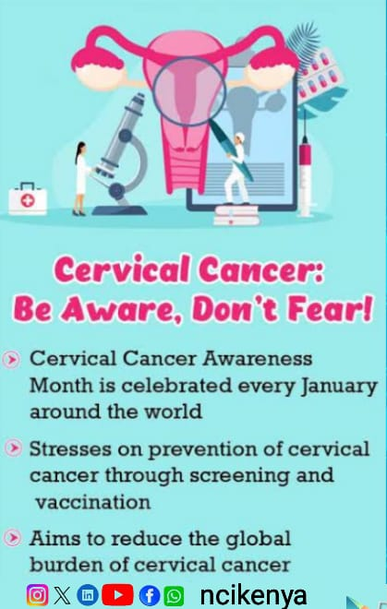 | For cancer patients, You are not in this battle alone. We are here standing with you and supporting you all along the way. Don't let Cervical cancer cause you to sell yourself short or forget your worth  #Hope  #Cervicalcancerawarenesmonth  #celebratesurvivors | For cancer patients, You are not in this battle alone. We are here standing with you and supporting you all along the way. Don't let Cervical cancer cause you to sell yourself short or forget your worth  #Hope  #Cervicalcancerawarenesmonth  #celebratesurvivors | For cancer patients, You are not in this battle alone. We are here standing with you and supporting you all along the way. Don't let Cervical cancer cause you to sell yourself short or forget your worth  #Hope  #Cervicalcancerawarenesmonth  #celebratesurvivors
 |  | No retreat! No surrender! The mission must be accomplished. We will win the war against #CervicalCancer  Where an armour of HPV vaccination and screening.  #Cervicalcancer #cancerawareness #Cervicalcancerawareness #ncikenya

#cervicalcancer is the second most reported cancer type in Kenya and the leading cause of cancer deaths among women, yet it is one of the cancers that can easily be prevented and controlled. Vaccination and screening can help control it.
#cervicalcancer #CancerAwareness

